ADVANCED DISTRIBUTION

AUTOMATION FUNCTIONS (ADA) FOR THE INTEGRATION OF RENEWABLE ENERGIES

**Report by:**

Pratik Sonthalia

[pratik.sonthalia@g2elab.grenoble-inp.fr](mailto:pratik.sonthalia@g2elab.grenoble-inp.fr)

**TEACHERS**

M.-C. ALVAREZ-HERAULT

[Marie-Cecile.Alvarez@g2elab.grenoble-inp.fr](mailto:Marie-Cecile.Alvarez@g2elab.grenoble-inp.fr)

Desk : 4-B-018

Contents

Part I: Study of the impacts of renewable connection to the distribution network. 3

Question N°1.1: for the first scenario, make a simulation over 1 year. Comment 3

Question N°1.2: what happens if the producers are based on wind power? 4

Question N°1.3: for each scenario detailed below, simulate the 5 step times pointed out in figure3. For each step times, in case of constraints, try to find the best settings of the OLTC of the three HV/MV substations. 5

Question N°1.4: Conclude on the impacts of renewable generation connected to the distribution network. 8

Part II: ADA (Advanced Distribution Automation functions) for the integration of renewable in distribution network. 8

Reconfiguration in Normal Mode 9

Question N°2.1: Find the optimal configuration for each scenarios and each step times of part I. 9

Question N°2.2: Does a unique configuration exist for the entire day enabling to respect the technical constraints of the network at each step times? 9

Question N°2.3: PREDIS experimentation 10

VVC (Volt Var Control) 11

Question N°2.4: Find the reactive settings of generators associated with the OLTC settings for each scenarios of part I and each step times. 11

Question N°2.5: Compare the results gotten with the ones of PREDIS experimentation provided by the teachers for the step time 13h. 12

Conclusion 12

Appendix 13

# Part I: Study of the impacts of renewable connection to the distribution network.

• Scenario N°1: connection of a photovoltaic producer (Gen 4) at the node N°13

• Scenario N°2: connection of a photovoltaic producer (Gen 4) at the node N°9.

• Scenario N°3: connection of two generators (Gen 3 and Gen 4) respectively at the node N°12 and N°13.

## Question N°1.1: for the first scenario, make a simulation over 1 year. Comment

**Description:** Photovoltaic producer (Pmax=4.7 MW) is connected at the Node 13.

**Observation:** There are 558 over-voltages observed. (Figure 1)

**Inference:** Over-voltages are a result of over-production of real power at a particular bus. Solar installations are modeled as constant power producing units.



Figure Schematic describing over-voltage for scenario 1

The likely cause can be over-voltages in buses 12 and 13 due to connection of solar power on bus 13. Solar provides maximum power of 4.7 MW during the day time at 1300 hours. During several hours (2886 hours [Appendix 2]) annually, the consumption at these buses (L7) is less than the power produced by the photovoltaic producer (G4). During these hours of over-production, the current flows back towards the substation. Since the substation bus is modeled as a constant voltage slack bus, it results in over-voltages in buses 12 and 13 in some scenarios. It is important to note that not all the 2886 hours lead to over-voltages. Only when difference in consumption and production is high that the voltages at these buses go beyond 1.05 pu, over-voltages are observed. An estimate of these hours has been plotted in Appendix 2.

Since the system is radial, other branches from the substation are not impacted by the introduction of photovoltaic generator at Bus 13.

## Question N°1.2: what happens if the producers are based on wind power?

**Description:** Wind power producer (Pmax=4.7 MW) is connected at the Node 13.

**Observation**: There are 194 over voltages observed.



Figure Schematic describing over-voltage in scenario 2

**Inference:** Overvoltages are a result of over-production of real power at a particular bus. The explanation follows the explanation for the previous analysis. However, the over-voltages observed are less as compared to solar power.

To explain this, similar analysis is performed on the difference in power generated as was performed for solar power. Although, the number of hours for which the wind power generation (7080 hours [Appendix 4]) was larger than power consumed by residential load, the over-voltages observed are far less. For solar power it was observed that during 558 over-voltage hours, the difference between the power produced by PV producers and the consumption was greater than 3.1233 MW. For the case of wind, only 185 such instances were observed. During the likely 195 observed over-voltages in case of wind-power, the difference between the power produced by PV producers and the consumption was greater than 3.11387 MW.

A comparative plot for wind and PV producer over-voltages has been plotted below. Clearly, the difference between the generated power and consumed power are greater for more instances in case of solar. Hence, wind power is more load-following as compared to solar power leading to less over-voltages in the buses.

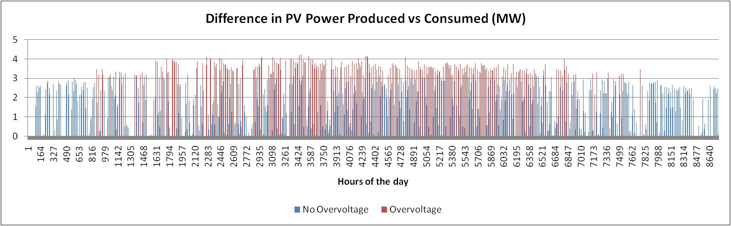

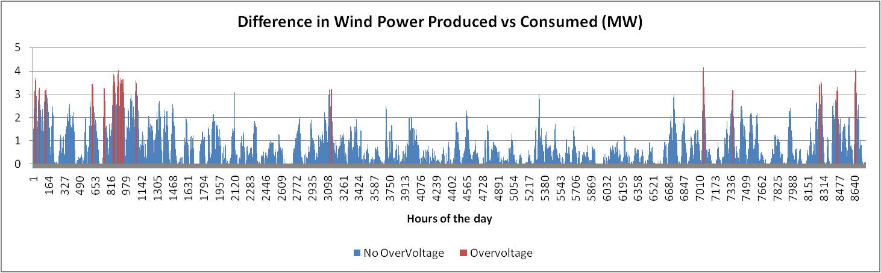

Figure Consumption and Production différences in Scenario 1 and 2, over-voltage hours (in red)

## Question N°1.3: for each scenario detailed below, simulate the 5 step times pointed out in figure3. For each step times, in case of constraints, try to find the best settings of the OLTC of the three HV/MV substations.

**Description:** For each of the scenario, the five time steps are simulated. For each time step, the generation power and the load power shall change according to the given load profile and the generation profile.

**Observations:**

Scenario 1: connection of a photovoltaic producer (Gen 4) at the node N°13

|  |  |  |  |  |  |  |  |  |  |  |  |
| --- | --- | --- | --- | --- | --- | --- | --- | --- | --- | --- | --- |
|  | **Load 6 Pl** | **Load 7 Pl** | **Load 9 Pl** | **Load 10 Pl** | **Gen 3 Pl** | **Gen 4 Pl** | **Gen 3 connection node** | **Gen 4 connection node** | **OLTC Node e 2** | **OLTC Node e 3** | **OLTC Node e 11** |
| 1 | 0.332 | 0.332 | 0.332 | 0.332 | 0 | 0 | 0 | 13 | 1.04 | 1.03 | 0.9750 |
| 2 | 0.638 | 0.638 | 0.638 | 0.638 | 0 | 4.465 | 0 | 13 | 1.03 | 1.03 | 0.95 |
| 3 | 0.60 | 0.60 | 0.60 | 0.60 | 0 | 4.7 | 0 | 13 | 1.03 | 1.03 | 0.95 |
| 4 | 0.498 | 0.498 | 0.498 | 0.498 | 0 | 2.9610 | 0 | 13 | 1.03 | 1.03 | 0.95 |
| 5 | 0.689 | 0.689 | 0.689 | 0.689 | 0 | 0 | 0 | 13 | 1.04 | 1.03 | 0.9750 |

(Screenshots attached in )

Scenario 2: connection of a photovoltaic producer (Gen 4) at the node N°9.

|  |  |  |  |  |  |  |  |  |  |  |  |
| --- | --- | --- | --- | --- | --- | --- | --- | --- | --- | --- | --- |
|  | **Load 6 Pl** | **Load 7 Pl** | **Load 9 Pl** | **Load 10 Pl** | **Gen 3 Pl** | **Gen 4 Pl** | **Gen 3 connection node** | **Gen 4 connection node** | **OLTC Node e 2** | **OLTC Node e 3** | **OLTC Node e 11** |
| 1 | 0.332 | 0.332 | 0.332 | 0.332 | 0 | 0 | 0 | 9 | 1.03 | 1.03 | 1 |
| 2 | 0.638 | 0.638 | 0.638 | 0.638 | 0 | 4.465 | 0 | 9 | 1.03 | 1.03 | 1 |
| 3 | 0.60 | 0.60 | 0.60 | 0.60 | 0 | 4.7 | 0 | 9 | 1.03 | 1.03 | 1 |
| 4 | 0.498 | 0.498 | 0.498 | 0.498 | 0 | 2.9610 | 0 | 9 | 1.03 | 1.03 | 1 |
| 5 | 0.689 | 0.689 | 0.689 | 0.689 | 0 | 0 | 0 | 9 | 1.04 | 1.03 | 1 |

(Screenshots attached in )

Scenario 3: connection of two generators (Gen 3 and Gen 4) respectively at the node N°12 and N°13.

|  |  |  |  |  |  |  |  |  |  |  |  |
| --- | --- | --- | --- | --- | --- | --- | --- | --- | --- | --- | --- |
|  | **Load 6 Pl** | **Load 7 Pl** | **Load 9 Pl** | **Load 10 Pl** | **Gen 3 Pl** | **Gen 4 Pl** | **Gen 3 connection node** | **Gen 4 connection node** | **OLTC Node e 2** | **OLTC Node e 3** | **OLTC Node e 11** |
| 1 | 0.332 | 0.332 | 0.332 | 0.332 | 0 | 0 | 12 | 13 | 1.04 | 1.03 | 0.9750 |
| 2 | 0.638 | 0.638 | 0.638 | 0.638 | 4.465 | 4.465 | 12 | 13 | 1.04 | 1.03 | 0.95 |
| 3 | 0.60 | 0.60 | 0.60 | 0.60 | 4.7 | 4.7 | 12 | 13 | 1.04 | 1.03 | 0.95 |
| 4 | 0.498 | 0.498 | 0.498 | 0.498 | 2.9610 | 2.9610 | 12 | 13 | 1.04 | 1.03 | 0.95 |
| 5 | 0.689 | 0.689 | 0.689 | 0.689 | 0 | 0 | 12 | 13 | 1.04 | 1.03 | 0.9750 |

(Screenshots attached in )

It is observed that in each of the scenario with some exceptions, for each of the time-step constraints could be avoided by using some OLTC setting for the nodes. For the scenario in which two generators were connected on Node 12 and 13, during the time-steps at hours 1200, 1300 and 1600, constraints could not have been avoided even by using OLTC. (Marked in red in the table)

**Inference:**

**For scenario No. 1**, the constraints were avoided by changing the OLTC. Since during some of the hours the power generation is greater than the consumption which can potentially lead to over-voltages, the OLTC setting for the node 11 is kept under 1. Similarly, since other branches emerging from Nodes 2 and 3 do not have any generation and are consuming power, it can potentially lead to under-voltage in some of the consumer buses. This is avoided by keeping the voltages at Node 2 and 3 above 1 pu.

**For scenario No. 2**, the constraints were avoided by changing the OLTC. Since during most of the hours the power generation is less than the consumption at the Nodes 9 and 8 (PL1 and PL10) which can potentially lead to under-voltages, the OLTC setting for the node 3 is kept above 1. Similarly, since other branches emerging from Nodes 2, 3, 11 do not have any generation and are consuming power, it can potentially lead to under-voltage in some of the consumer buses. This is avoided by keeping the voltages at Node 2 above 1 pu. Node 11 is kept at 1 since there is a very small load connected to the branch which potentially cannot lead to any under-voltage.



Figure Schematic describing OLTC setting for Scenario 2

**For scenario 3**, the two generators (each with peak power of 4.7 MW) are connected on the same branch emerging from Node 11 at Nodes 12 and 13. This branch has a very small residential load of peak 1 MW. Hence during day time of high PV power production (1200, 1300 and 1600 hours) there is a huge difference between the power produced and consumed from Node 11 resulting in high current towards Node 11. Even though, the OLTC for Node 11 is set to 0.95 pu, it will result in over-voltages in Nodes 12 and 13. Hence, the constraint cannot be avoided.



Figure Scehmatic describing OLTC for scenario 3

## Question N°1.4: Conclude on the impacts of renewable generation connected to the distribution network.

As seen from demonstrations above that renewable energy integration at the distribution can be challenging when trying to operate the grid within the constraints. With higher solar PV integration in areas of lower consumption, OLTC may not be enough to keep the voltages within safe limits. Reconfiguration or additional operations may be required to keep the voltages within the range.

# Part II: ADA (Advanced Distribution Automation functions) for the integration of renewable in distribution network.

## Reconfiguration in Normal Mode

### Question N°2.1: Find the optimal configuration for each scenarios and each step times of part I.

**Observations:**

**Scenario 1:** connection of a photovoltaic producer (Gen 4) at the node N°13

|  |  |  |  |  |  |  |  |  |  |
| --- | --- | --- | --- | --- | --- | --- | --- | --- | --- |
|  | Load 6 Pl | Load 7 Pl | Load 9 Pl | Load 10 Pl | Gen 3 Pl | Gen 4 Pl | Gen 3 connection node | Gen 4 connection node | Optimal Configuration |
| 1 | 0.332 | 0.332 | 0.332 | 0.332 | 0 | 0 | 0 | 13 | 4 14 6 8 7 |
| 2 | 0.638 | 0.638 | 0.638 | 0.638 | 0 | 4.465 | 0 | 13 | 4 6 8 7 15 |
| 3 | 0.60 | 0.60 | 0.60 | 0.60 | 0 | 4.7 | 0 | 13 | 4 6 8 7 15 |
| 4 | 0.498 | 0.498 | 0.498 | 0.498 | 0 | 2.9610 | 0 | 13 | 4 6 8 15 7 |
| 5 | 0.689 | 0.689 | 0.689 | 0.689 | 0 | 0 | 0 | 13 | 6 4 16 8 7 |

(Screenshots attached in )

**Scenario 2:** connection of a photovoltaic producer (Gen 4) at the node N°9.

|  |  |  |  |  |  |  |  |  |  |
| --- | --- | --- | --- | --- | --- | --- | --- | --- | --- |
|  | Load 6 Pl | Load 7 Pl | Load 9 Pl | Load 10 Pl | Gen 3 Pl | Gen 4 Pl | Gen 3 connection node | Gen 4 connection node | Optimal Configuration |
| 1 | 0.332 | 0.332 | 0.332 | 0.332 | 0 | 0 | 0 | 9 | 4 14 6 8 7 |
| 2 | 0.638 | 0.638 | 0.638 | 0.638 | 0 | 4.465 | 0 | 9 | 4 6 8 7 15 |
| 3 | 0.60 | 0.60 | 0.60 | 0.60 | 0 | 4.7 | 0 | 9 | 6 4 16 8 7 |
| 4 | 0.498 | 0.498 | 0.498 | 0.498 | 0 | 2.9610 | 0 | 9 | 6 4 17 8 7 |
| 5 | 0.689 | 0.689 | 0.689 | 0.689 | 0 | 0 | 0 | 9 | 6 4 16 8 7 |

(Screenshots attached in )

**Scenario 3:** connection of two generators (Gen 3 and Gen 4) respectively at the node N°12 and N°13.

|  |  |  |  |  |  |  |  |  |  |
| --- | --- | --- | --- | --- | --- | --- | --- | --- | --- |
|  | Load 6 Pl | Load 7 Pl | Load 9 Pl | Load 10 Pl | Gen 3 Pl | Gen 4 Pl | Gen 3 connection node | Gen 4 connection node | Optimal Configuration |
| 1 | 0.332 | 0.332 | 0.332 | 0.332 | 0 | 0 | 12 | 13 | 4 14 6 8 7 |
| 2 | 0.638 | 0.638 | 0.638 | 0.638 | 4.465 | 4.465 | 12 | 13 | 16 4 6 8 7 |
| 3 | 0.60 | 0.60 | 0.60 | 0.60 | 4.7 | 4.7 | 12 | 13 | 16 4 6 8 7 |
| 4 | 0.498 | 0.498 | 0.498 | 0.498 | 2.9610 | 2.9610 | 12 | 13 | 16 4 6 8 7 |
| 5 | 0.689 | 0.689 | 0.689 | 0.689 | 0 | 0 | 12 | 13 | 6 4 16 8 7 |

(Screenshots attached in )

### Question N°2.2: Does a unique configuration exist for the entire day enabling to respect the technical constraints of the network at each step times?

No, a unique configuration doesn’t exist for the entire day enabling to respect the technical constraints of the network at each step times. Also, reconfiguration is not sufficient to keep the voltages in the safe operating region in some cases.

### Question N°2.3: PREDIS experimentation

**This year, you cannot make experiments on the PREDIS platform. Then the teachers will provide the results for the scenarios 1, 2 and 3 of part I with the associate OLTC settings and with the optimal configurations found for the step time 13h.**

* **Check the results of your simulations with the ones of the PREDIS experimentation.**
* **Conclude**

The optimal reconfiguration results achieved from Scenario 1 13h are shown below. Please note that the settings are not exactly as described in the scenario because of step limitations in PREDIS.

|  |  |  |  |  |  |  |  |  |  |  |  |  |  |
| --- | --- | --- | --- | --- | --- | --- | --- | --- | --- | --- | --- | --- | --- |
|  | Load 1 | Load 2 | Load 6 Pl | Load 7 Pl | Load 9 Pl | Load 10 Pl | Gen 3 Pl | Gen 4 Pl | Gen 3 connection node | Gen 4 connection node | OLTC N2 | OLTC N3 | OLTC N11 |
| S 1 | 3.23+0.46i | 3.23+0.66i | 0.6 | 0.6 | 0.6 | 0.8 | 0 | 4.68+0.03i | 10 | 13 | 419.1 | 398.4 | 380 |

Upon running the Load Flow for the above settings, a small error was observed between the experimented and simulated values [Screenshot in Appendix 7]:

Error between the voltages at Buses 9, 5, 10 and 12 are observed to be -0.0033 % 0.7192 % 0.1247 % 0.2826 % respectively.

Error can be a result of:

1. Error in sensors
2. Loads and productions vary during time
3. Uncertainities in R and X

Also, as noticed, even after having OLTC settings, there is an over-voltage observed at node N13 (428.6681 V). Hence, we look for the optimal reconfiguration of the system. The optimal configuration was found to be 4 6 8 7 15. However, the system still had a slight over-voltage after reconfiguration. That can be avoided using OLTC.

The OLTC setting is used as described in PREDIS

|  |  |  |  |  |  |  |  |  |  |  |  |  |
| --- | --- | --- | --- | --- | --- | --- | --- | --- | --- | --- | --- | --- |
|  | Before Reconfiguration  Initial Open Switches: 8 10 12 13 17 | | | | | | After Reconfiguration  Reconfigured Open Switches: 4 6 8 7 15 | | | | | |
|  | Without OLTC setting | | | With OLTC  N1- 419.1  N2- 398.4 V  N11- 380 V | | | Without OLTC | | | With OLTC  N1- 400.90 V  N2- 395 V  N11- 404.1 V | | |
|  | Minimum Voltage | Maximum Voltage | Plosses | Minimum Voltage | Maximum Voltage | Plosses | Minimum Voltage (pu) | Maximum Voltage (pu) | Plosses | Minimum Voltage (pu) | Maximum Voltage (pu) | Plosses |
| S 1 | 0.9117 | 1.1189 | 10.8161 | 0.95 (380/400) | 1.0716 (428.6681/400) | 10.8760 | 0.9863 | 1.0549 | 3.0810 | 0.9797 (391.8973/400) | 1.0429 (417.1871/400) | 3.1386 |

The optimal configuration results are closer to that from PREDIS experiment. The error between the voltages at Buses 9, 5, 10 and 12 are observed to be 0.7104 0.4518 0.0857 -0.3626 respectively.

[Appendix 7]

## VVC (Volt Var Control)

Producers can inject or absorb reactive power on the distribution network. Today, the reactive setting of producers is fixed (or equal to 0). The injection/ absorption of reactive power tend to increase power losses. The objective here is to found the optimal reactive settings of generators that minimize power losses and enable to respect the technical constraints.

Based on above explanation, an objective function is formed as:

$$Objective Function={Minimise}_{X}\left(\sum{Reactive Power Injection}\right)=\sum_{i=Gen Buses}{Q_{i}}$$

Subject to conditions:

$$0.95 pu< V_{i}<1.05 pu, i=\{1,2,……, 14\}$$

Where

$$X=\{V2, V3, V11, Q1, Q2\}$$

Nodes 2, 3 and 11 are

Q1, Q2…. Are the distributed generators.

### Question N°2.4: Find the reactive settings of generators associated with the OLTC settings for each scenarios of part I and each step times.

For the system given in PREDIS system

|  |  |  |  |  |  |  |  |  |  |  |  |  |  |
| --- | --- | --- | --- | --- | --- | --- | --- | --- | --- | --- | --- | --- | --- |
|  | Load 1 | Load 2 | Load 6 Pl | Load 7 Pl | Load 9 Pl | Load 10 Pl | Gen 3 Pl | Gen 4 Pl | Gen 3 connection node | Gen 4 connection node | OLTC N2 | OLTC N3 | OLTC N11 |
| S 1 | 3.23+0.46i | 3.23+0.66i | 0.6 | 0.6 | 0.6 | 0.8 | 0 | 4.68+0.03i | 10 | 13 | 419.1 | 398.4 | 380 |



The objective is to calculate the most optimum voltage setting at nodes N2, N3 and N11 and the reactive power generation at generator G4 at Node 13. The premise is that lowest reactive power injection into the system shall lead to least active power losses and help in respecting the technical constraints.

The result was found to be:

|  |  |  |  |  |
| --- | --- | --- | --- | --- |
|  | V N2 in pu/ V | V N3 in pu/ V | V N11 in pu/ V | Q4 in kVaR |
| S 1 | 1.04 pu (416 V) | 1 pu (400 V) | 0.95 pu (380 V) | -0.3734 kVaR |

The reactive power generation has to be 0.3734 kVaR. Codes are attached as zip in the project folder.

### Question N°2.5: Compare the results gotten with the ones of PREDIS experimentation provided by the teachers for the step time 13h.

Using the system described here, the error between PREDIS results and simulations are calculated. The error between the voltages at Buses 9, 5, 10 and 12 are observed to be -0.3001 0.5911 0.0199 0.3140 respectively.

### Conclusion

We can conclude from the results that with distributed generation, both OLTC and reconfiguration will be required to keep the voltage within limits. Secondly, the reconfiguration optimization condition to minimize the power losses may not be the best condition as it is seen that there are still over-voltages and is based on a premise that least reactive power injection leads to least active power losses in the line. This may not be always true. This is observed when the optimal reconfiguration is performed and OLTC settings are changed. The power losses are higher as compared to without OLTC but the voltage settings are within the limits. Best would be to minimize the power losses but may be a computational overhead to form the optimization condition. However, the results achieved using the condition of least reactive power is satisfactory and works for the system.

# Appendix

## Appendix 1

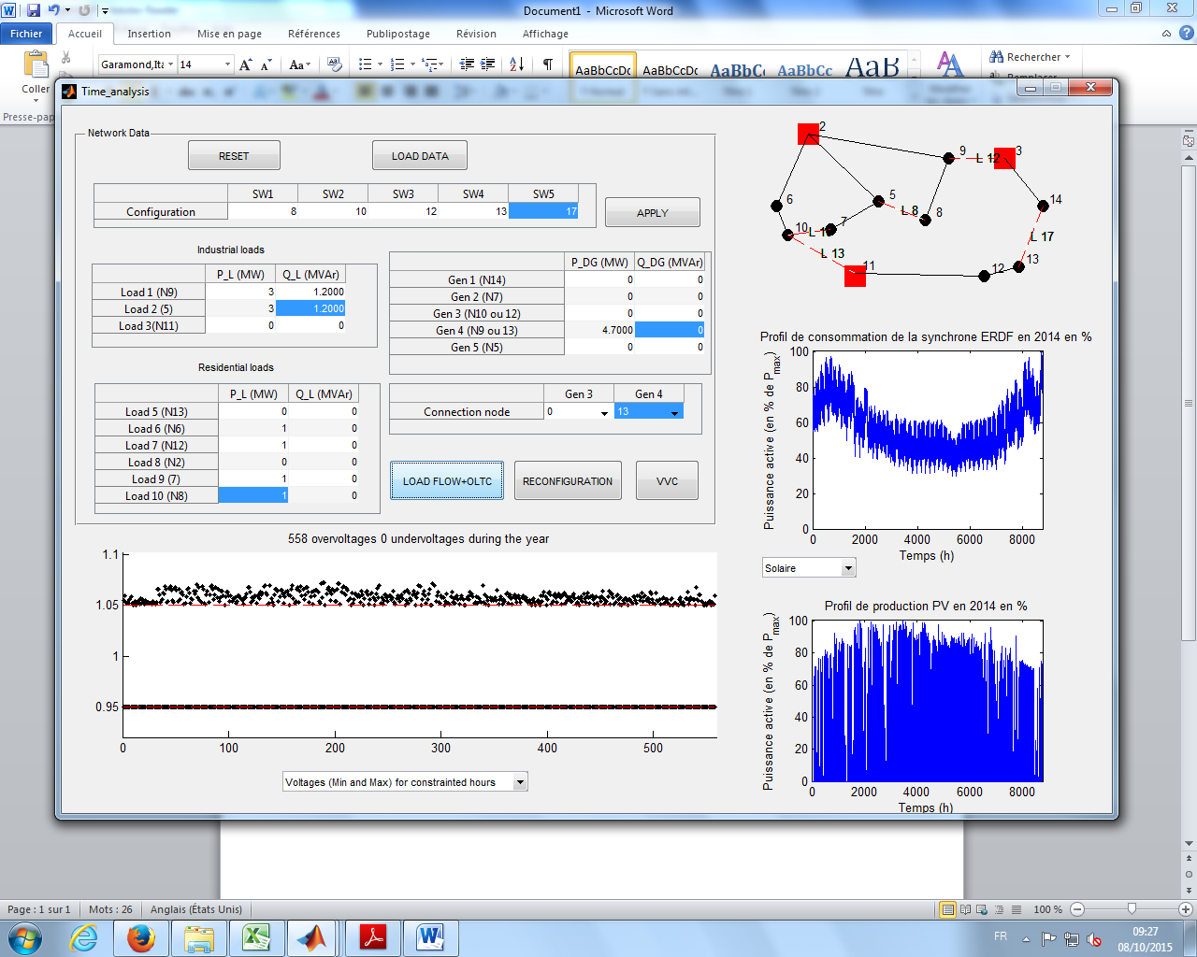

Figure Part 1 Scenario 1 Simulation Screenshot

## Appendix 2





Above are the normalized August month residential consumption and PV generation profile. The annual load profile and generation profile is obtained from the data provided in the problem statement.

Since the Pmax for residential load is 1 MW and PV generator is 4.7 MW, the number of hours during which the generation is higher than the consumption can be calculated. The calculation is attached in the excel sheet below.



There are 2886 such hours observed during the year. These are mostly during the day time when PV generation reaches its peak and more so during the summer as compared to the winter.

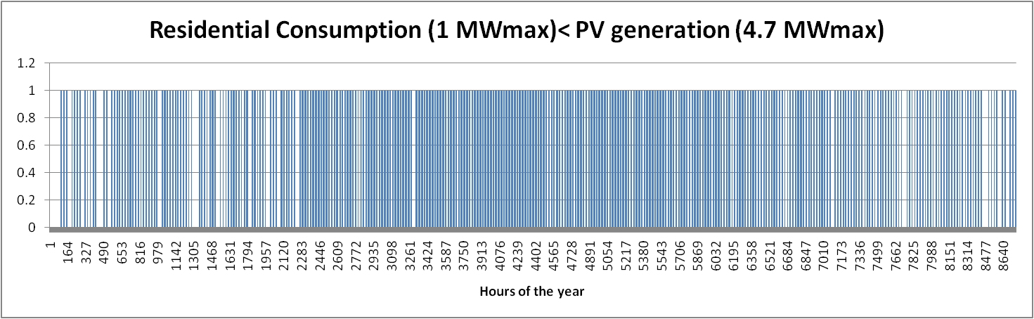

Figure For scenario 1, the cases when the PV generation is greater than consumption

The blue lines indicate the hours during which the residential consumption (1 MW peak) was less than PV Generation (4.7 MW peak).

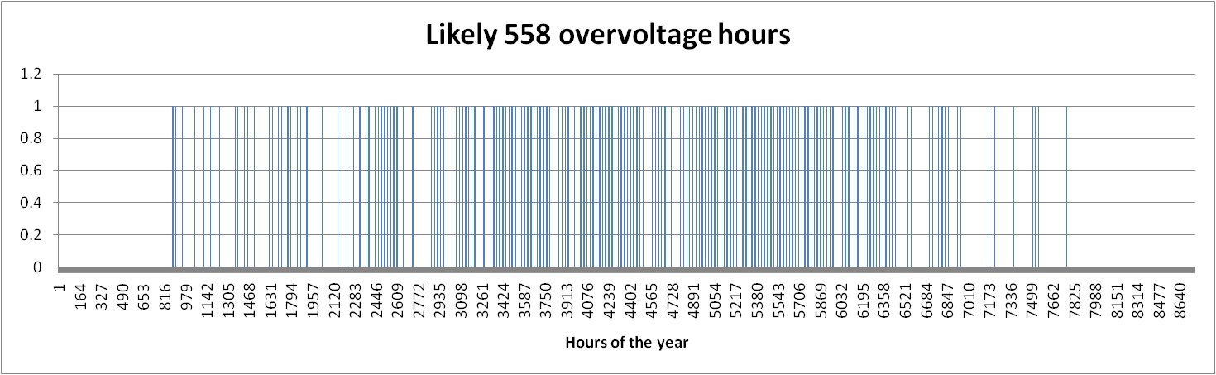

Figure The likely hours during which overvoltages are observed for Scenario No 1

The likely over-voltage hours have been plotted. The maximum 558 differences in the production and generation were identified and estimated to have resulted in over-voltage. During these hours, the difference between the power generated by PV producers and power consumed by residential loads was greater than 3.1233 MW.

## Appendix 3

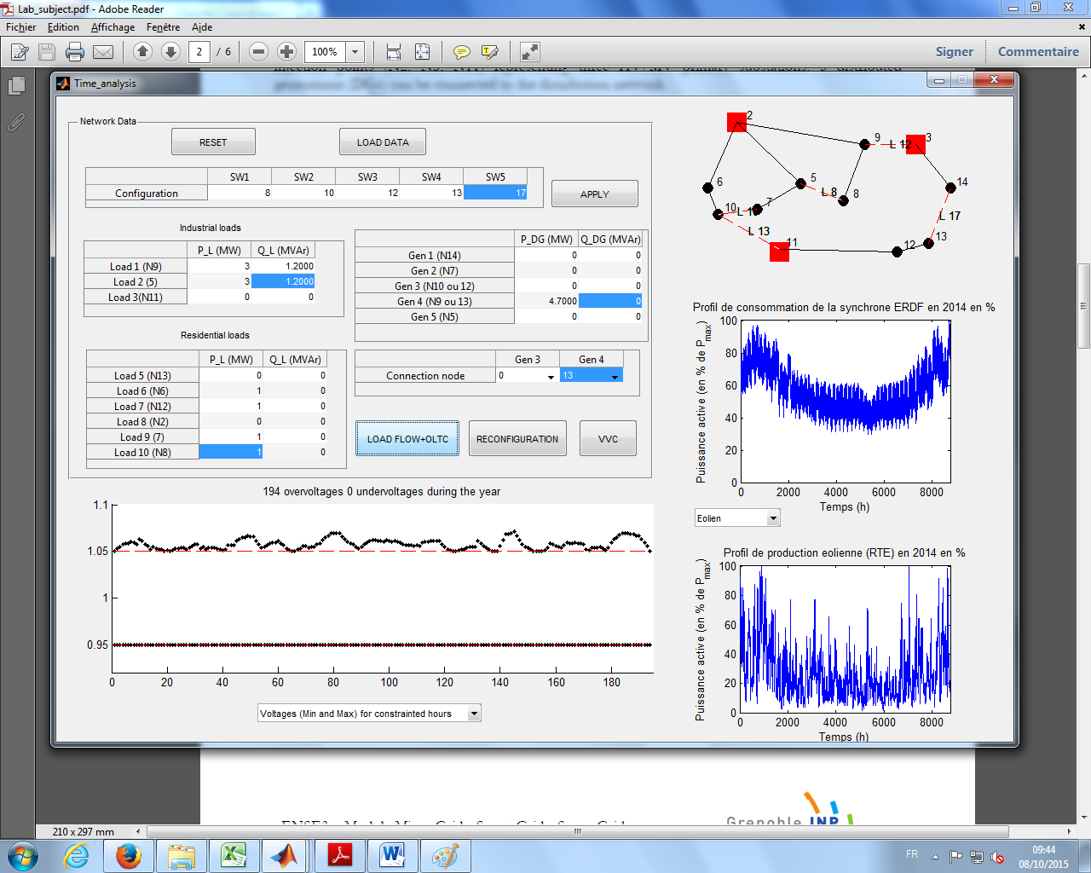

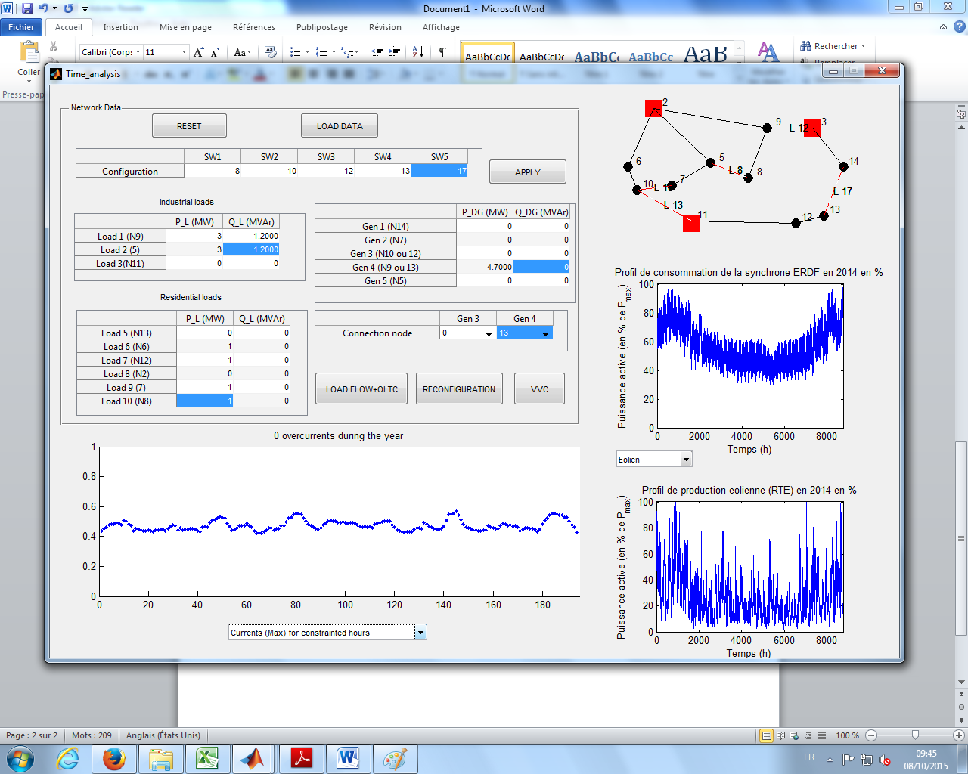

## Appendix 4

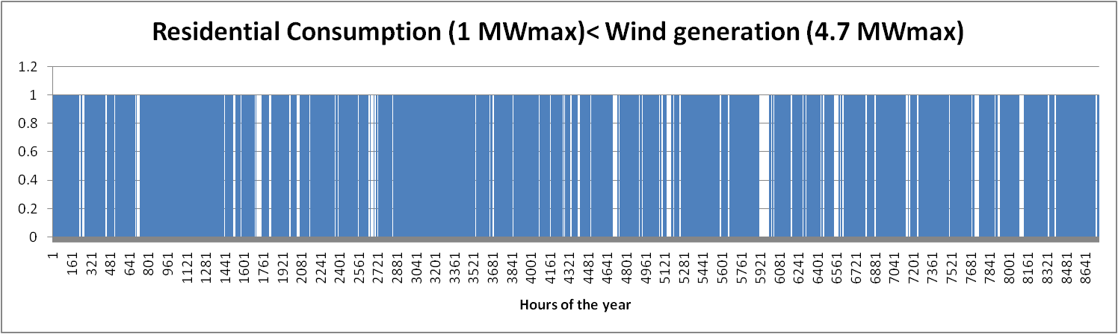

Figure For scenario 2, the cases when the residential consumption is less than the PV generation

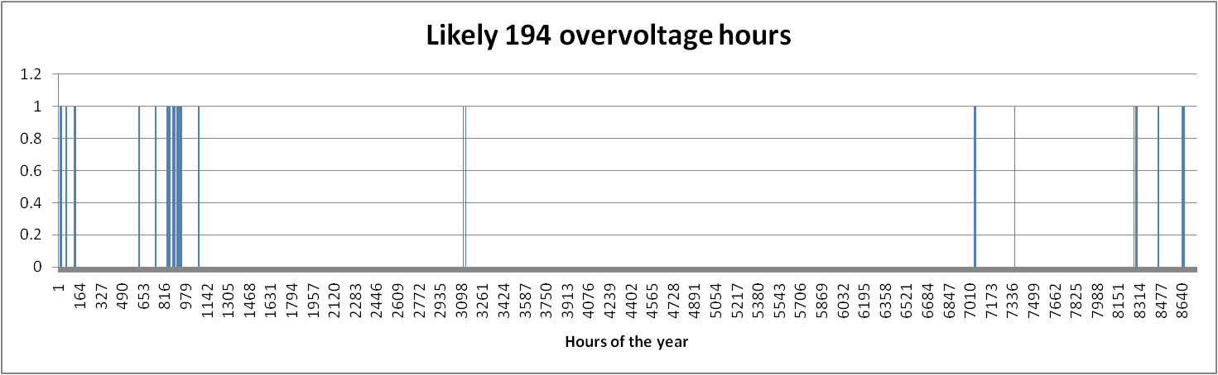

Figure For Scenario 2, the likely cases when overvoltages are observed

## Appendix 5

### Scenario 1:

|  |  |
| --- | --- |
|  |  |
| 1 |  |
| 2 |  |
| 3 |  |
| 4 |  |
| 5 |  |

### Scenario 2:

|  |  |
| --- | --- |
|  |  |
| 1 |  |
| 2 |  |
| 3 |  |
| 4 |  |
| 5 |  |

### Scenario 3:

|  |  |
| --- | --- |
|  |  |
| 1 |  |
| 2 |  |
| 3 |  |
| 4 |  |
| 5 |  |

## Appendix 6

### Scenario 1:

|  |  |
| --- | --- |
|  |  |
| 1 |  |
| 2 |  |
| 3 |  |
| 4 |  |
| 5 |  |

### Scenario 2:

|  |  |
| --- | --- |
|  |  |
| 1 |  |
| 2 |  |
| 3 |  |
| 4 |  |
| 5 |  |

### Scenario 3:

|  |  |
| --- | --- |
|  |  |
| 1 |  |
| 2 |  |
| 3 |  |
| 4 |  |
| 5 |  |

## Appendix 7

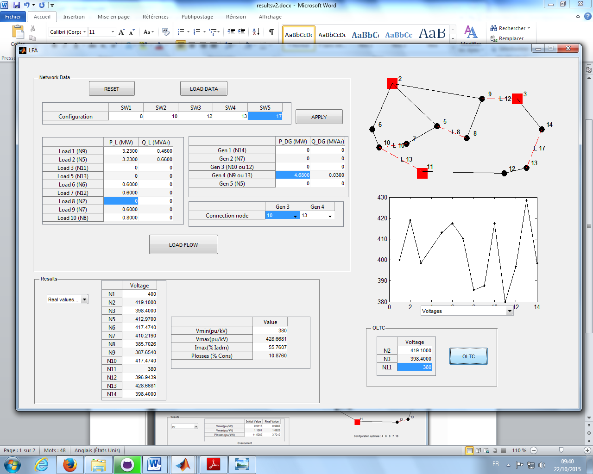

Figure Load Flow results for Scenario 1 with OLTC using initial grid setting

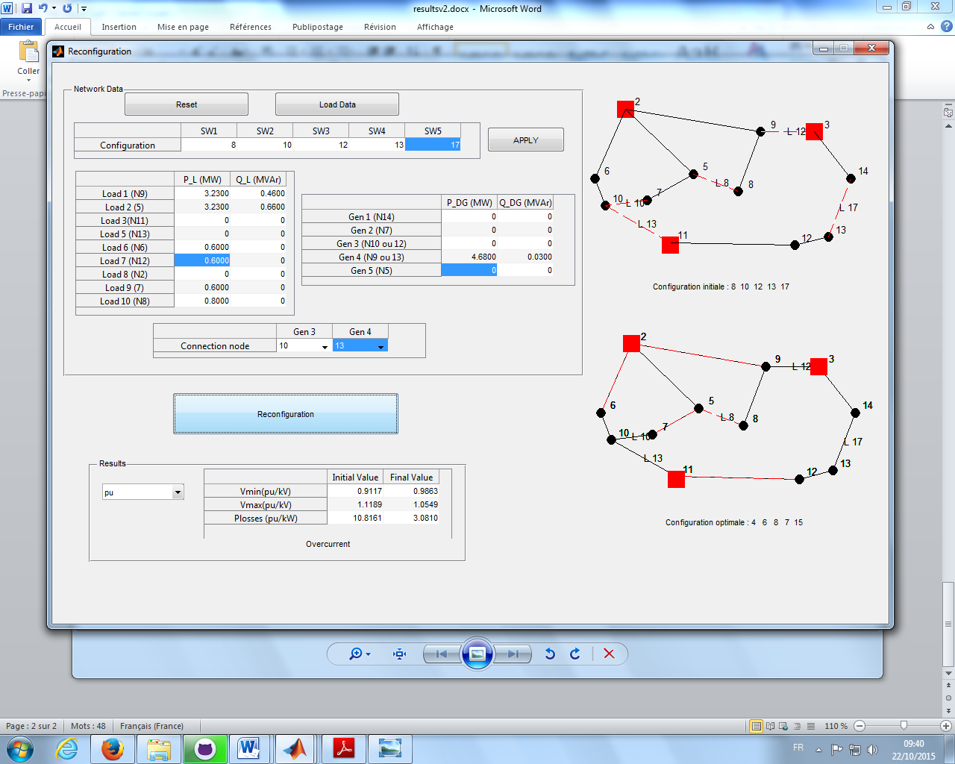

Figure Optimal reconfiguration of the grid

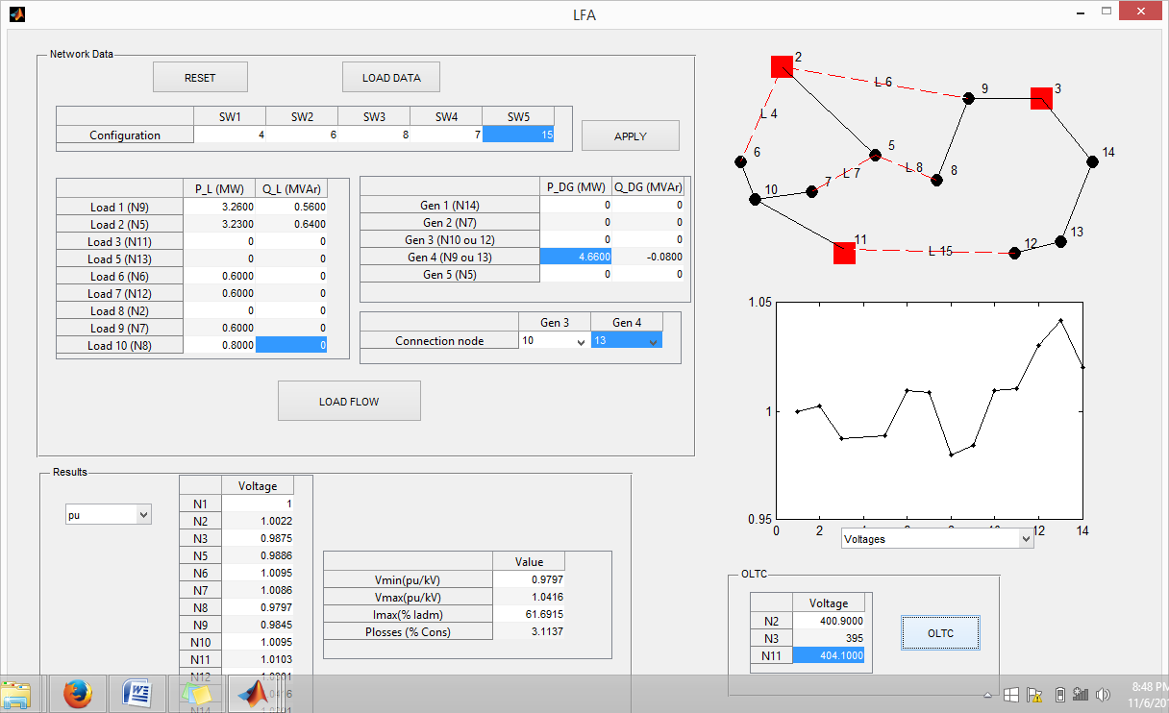

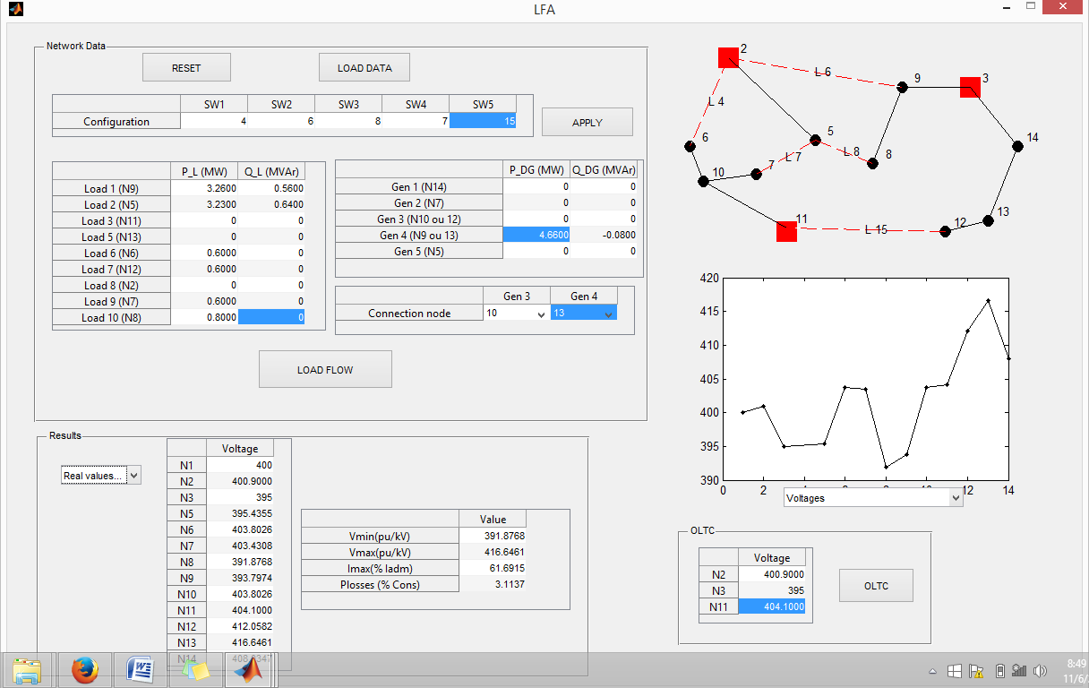

Figure Load Flow results for optimally reconfigured grid with OLTC

PREDIS Experiment result



## Appendix 8

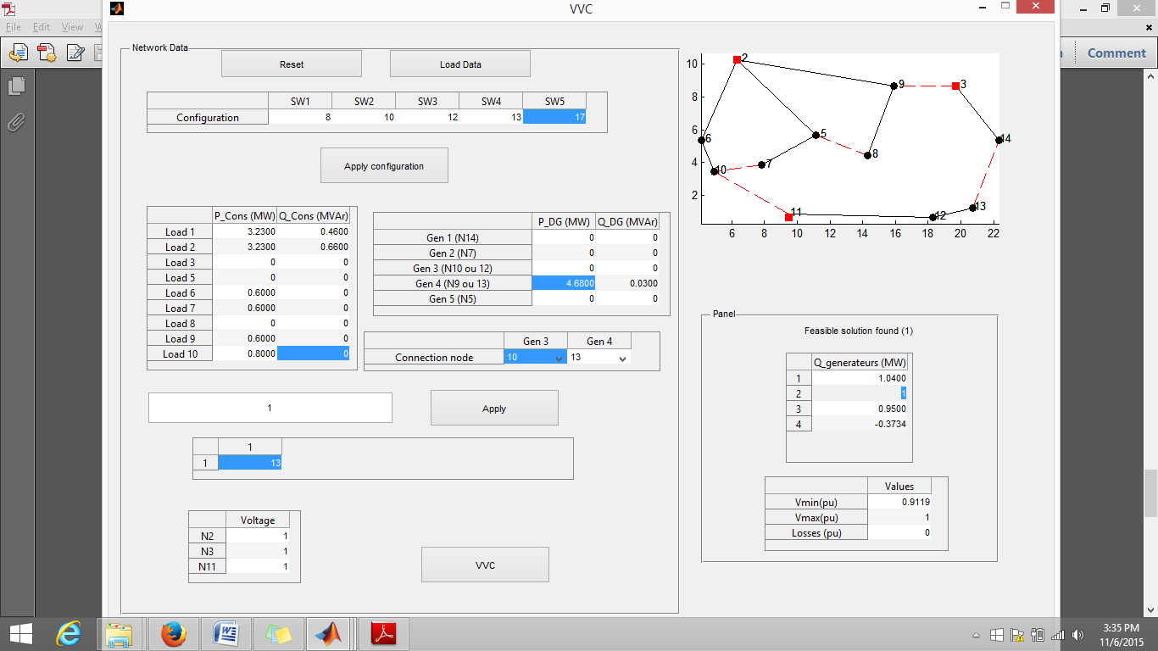

Figure Screenshot showing the optimal reactive power generation

